LAB 06 Output Snippets

Task-1

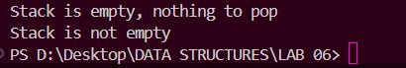

Task-2

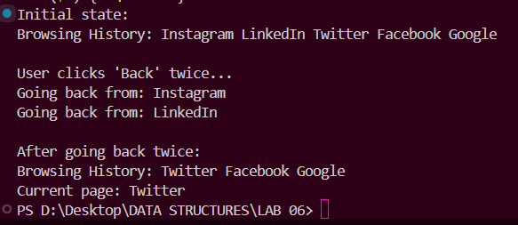

Task-3

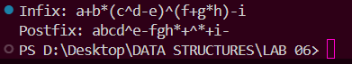

Task-4

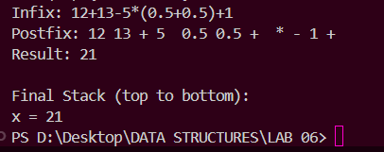

Task-5

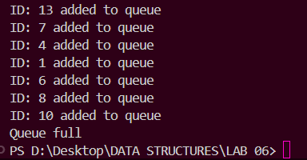

Task-6

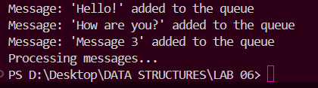

Task-7

